Software Verification & Validation (Lab)
  - Lab Task - 02
  - Requirement Analysis and Defect Logging

Submitted to
Ma’am Javaria Ramzan

Submitted by
Abdul Wahab
Fa-2023 / BSSE / Sec-A / 037

Department of Software Engineering
Lahore Garrison University

Task A - Defect Hunt (Minimum 15 Defects)

🔴 Inconsistencies (5)

1. R2 vs R3
R2 says registration is not allowed after the deadline.
R3 allows late registration for 3 days.
Type: Inconsistency

2. R4 vs R5
R4 shows available seats.
R5 allows registration even if seats are full.
Type: Inconsistency

3. R9 vs R10
R9 prevents schedule conflicts.
R10 allows same-time courses if one is online.
Type: Inconsistency

4. R11 vs R12
R11 limits to 18 credit hours.
R12 allows 24 with advisor approval.
Type: Inconsistency

5. R13 vs R15
R13 allows drop until Week 6.
R15 says drops not allowed after deadline (deadline undefined).
Type: Inconsistency

🟡 Incompleteness (5)

6. R6
Confirmation method not specified (email? SMS?).

7. R8
Instructor approval process not defined.

8. R14
Drop fee amount not mentioned.

9. R16
Maximum waitlist size not defined.

10. R19
Priority enrollment rule not explained.

🟠 Ambiguities (3)

11. R6
Confirmation type unclear.

12. R8
Approval process unclear.

13. R20
"Quickly" is vague.

🔵 Unverifiable (2)

14. R20
Cannot test “quickly”.

15. R6
Confirmation timing not measurable.

Task B - Defect Logging (GitHub Issues)

The identified defects from Task A were logged as GitHub issues in the project repository. Each issue includes a clear title, requirement ID, defect type, description, impact, suggested fix, and priority level.
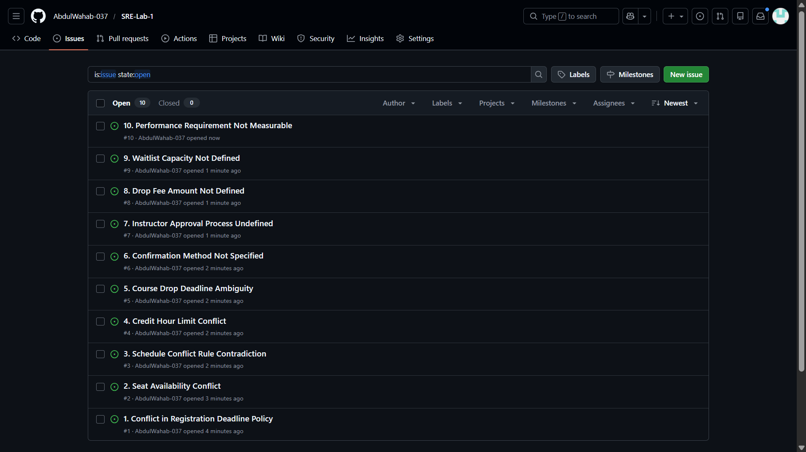

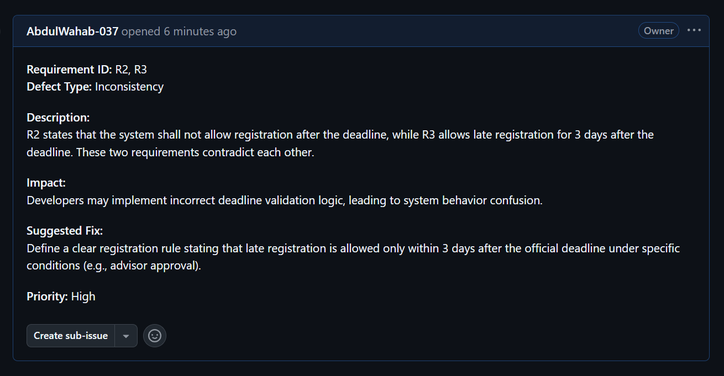

Below are the logged defects:

🔴 Issue 1
Title: Conflict in Registration Deadline Policy
Requirement ID: R2, R3
Defect Type: Inconsistency
Description: R2 states that the system shall not allow registration after the deadline, while R3 allows late registration for 3 days after the deadline. These two requirements contradict each other.
Impact: Developers will be confused about whether registration should be blocked or allowed after the deadline, leading to incorrect system implementation.
Suggested Fix: Clearly define the registration deadline rule and specify that late registration is allowed only within 3 days under defined conditions (e.g., advisor approval).
Priority: High

🔴 Issue 2
Title: Seat Availability Conflict
Requirement ID: R4, R5
Defect Type: Inconsistency
Description: R4 states that the system shall show available seats for each course, while R5 allows registration even if seats are full. This creates a logical contradiction.
Impact: The system may allow over-enrollment or create confusion regarding seat limits.
Suggested Fix: Modify R5 to specify that students should be placed on a waitlist when seats are full instead of direct registration.
Priority: High

🔴 Issue 3
Title: Schedule Conflict Rule Contradiction
Requirement ID: R9, R10
Defect Type: Inconsistency
Description: R9 prevents schedule conflicts, but R10 allows students to register for two courses occurring at the same time if one is online. The exception is not clearly integrated.
Impact: The system may either block valid registrations or allow invalid overlaps.
Suggested Fix: Update R9 to explicitly include the exception for online courses.
Priority: High

🔴 Issue 4
Title: Credit Hour Limit Conflict
Requirement ID: R11, R12
Defect Type: Inconsistency
Description: R11 limits students to 18 credit hours per semester, while R12 allows up to 24 credit hours with advisor approval.
Impact: Without clarification, the system may incorrectly restrict or allow excessive credit hours.
Suggested Fix: Clearly state that the default limit is 18 credit hours and can be extended to 24 only with documented advisor approval.
Priority: High

🔴 Issue 5
Title: Course Drop Deadline Ambiguity
Requirement ID: R13, R15
Defect Type: Inconsistency
Description: R13 allows students to drop courses until Week 6, while R15 states that course drops are not allowed after the deadline. The deadline is not clearly defined.
Impact: This may result in incorrect enforcement of drop policies.
Suggested Fix: Define a single clear deadline (e.g., Week 6 is the final drop deadline).
Priority: Medium

🟡 Issue 6
Title: Confirmation Method Not Specified
Requirement ID: R6
Defect Type: Incompleteness
Description: R6 states that the system shall send confirmation but does not specify the method (email, SMS, system notification).
Impact: Developers may implement inconsistent confirmation methods.
Suggested Fix: Specify the confirmation type (e.g., email confirmation sent within 2 minutes).
Priority: Medium

🟡 Issue 7
Title: Instructor Approval Process Undefined
Requirement ID: R8
Defect Type: Incompleteness
Description: R8 states that prerequisites may be ignored if the instructor approves, but it does not describe how approval is recorded or verified.
Impact: The system cannot properly implement prerequisite overrides without a defined approval process.
Suggested Fix: Define a clear digital approval workflow inside the system.
Priority: Medium

🟡 Issue 8
Title: Drop Fee Amount Not Defined
Requirement ID: R14
Defect Type: Incompleteness
Description: R14 states that a fee will be charged for dropping courses after Week 2 but does not specify the amount or calculation method.
Impact: Financial calculation cannot be implemented accurately.
Suggested Fix: Specify the exact fee amount or percentage.
Priority: Low

🟡 Issue 9
Title: Waitlist Capacity Not Defined
Requirement ID: R16
Defect Type: Incompleteness
Description: The requirement states that the system shall support waitlisting but does not define maximum waitlist size or management rules.
Impact: The system may allow unlimited waitlisted students, causing management issues.
Suggested Fix: Define maximum waitlist size and management policy.
Priority: Low

🔵 Issue 10
Title: Performance Requirement Not Measurable
Requirement ID: R20
Defect Type: Unverifiable Requirement
Description: R20 states that students shall be able to register quickly, but the term “quickly” is vague and not measurable.
Impact: The requirement cannot be tested or validated during system testing.
Suggested Fix: Replace with a measurable requirement (e.g., registration process shall complete within 2 minutes).
Priority: Medium

Task C - Rewritten Correct Requirements (8)

- The system shall allow students to register for courses through the online portal.
- The system shall allow late registration up to 3 days after the official deadline with advisor approval.
- The system shall display real-time available seats for each course.
- The system shall automatically place students on a waitlist when seats are full.
- The system shall send email confirmation within 2 minutes after successful registration.
- The system shall prevent registration if prerequisites are not completed unless instructor approval is recorded.
- The system shall prevent schedule conflicts except when one course is fully online.
- The system shall limit students to 18 credit hours per semester, or 24 with advisor approval.


